**NAME____________________________ADM NO.________CLASS______**

**231/1**

**BIOLOGY (Theory)**

**March/April 2024**

**2 Hours**

**KENYA CERTIFICATE OF SECONDARY EDUCATION**

**FORM FOUR BIOLOGY PAPER 1**

Instructions to Candidates

* Write your Name and admission Number in the Spaces Provided.
* Sign and write date of examination in the spaces provided.
* You should check the question paper to ascertain that all the pages are printed as indicated and that no questions are missing.

***Answer all the questions in the spaces provided.***

1. State three importance of osmosis in plants. (3mks)

2.Name the organelle that:

1. is the most abundant in skeletal muscle cell (1mk)

1. assist in the formation of spindle fibres during cell division. (1mk)

3.(i) Identify the nuclei acid whose base sequence is shown below. (1mark)

G - A - C - U - A - G - C - G – U

(ii) Give a reason for your answer in (i) above (1mark)

(iii) If this nucleic acid was involved in protein synthesis, how many amino acids would be present in the protein synthesized. (2mks)

4.The diagram below represents a structure found in plants.

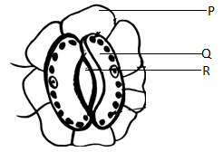

(a) Name the parts labelled **P** and **R** (2mks)

P -

R -

(b) **State** how cell Q is adapted to its function (2mks)

5.The diagram below represents a certain organism collected by a student on his way to school

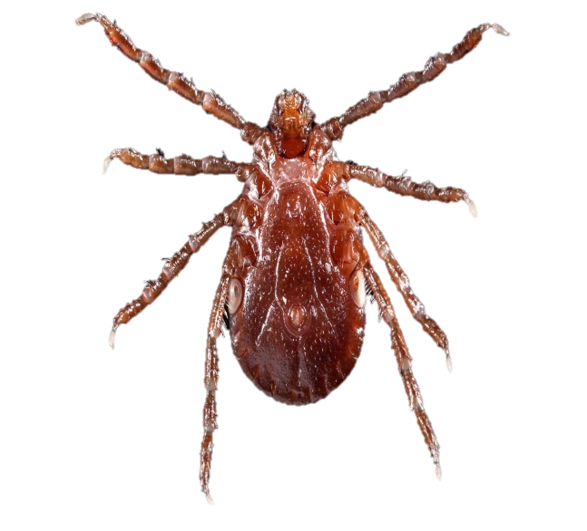

a) State the class to which the organism belongs. (1mk)

b) Give two reasons for your answer in (a) above. (2mks)

6. State three reasons why green plants are included in the fish aquarium. (3mks)

7. State two adaptations of the alveolus to its functions. (2mks)

8(a)Why may an asthmatic patient produce a wheezing sound during breathing? (1mk)

(b) What is the significance of the cartilage found in the human trachea being incomplete (C- shaped rings) (1mk)

9. a) State **three** characteristics of Monera that are not found in other kingdoms. (3mks)

b) Name the class to which a dolphin belongs. (1mk)

10.a) Obesity increases the risk of a person developing cardiovascular disease and losing weight

can reduce the risk of this disease occurring. Explain why exercise can cause weight loss (2mks)

(b)The Figure below shows a gastric band fitted to a stomach.

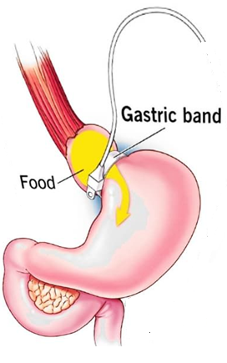

Explain how a gastric band helps a person to lose weight. (2mks)

11. a) What is genetic engineering? (1mk)

b) What is meant by hybrid vigour? (1mk)

12. How is the mammalian fallopian tube adapted to its function. (2mks)

13. The diagram below shows a transverse section of a leaf.

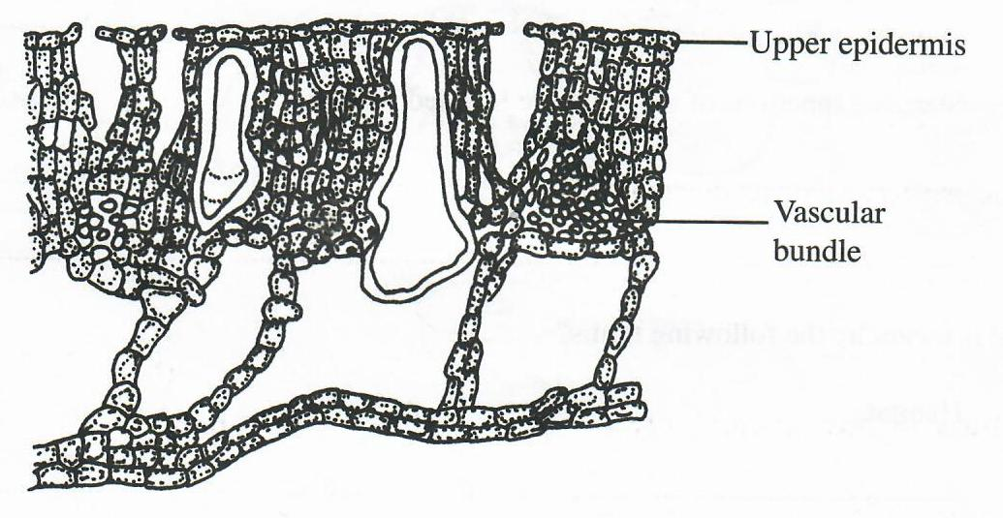

1. Name the habitat of the plant from which the leaf was obtained. (1mk)

1. Give two reasons for your answer in (a) above. (2mks)

14. Identify the function of a light microscope as shown by the following diagrams. (2mks)

(a)

(b)

15.(a) State three structural differences between arteries and veins. (3mks)

|  |  |
| --- | --- |
| **Arteries** | **Veins** |
|  |  |
|  |  |
|  |  |

(b)Explain why phloem cells are not lignified like the xylems. (1mk)

16.What is meant by the term habitat. (1mk)

17.State two ways through which flowering plants hinder self-fertilization from occurring.(2mks)

18.(a)The study of microorganisms is called microbiology. Name any two branches of microbiology. (2mks)

b) Name the branch of biology that deals with the study of the Phylogenetic relationship among organism (1mk)

19. Below is a drawing of an apparatus used during the study of biology.

1. Identify the apparatus. (1mk)

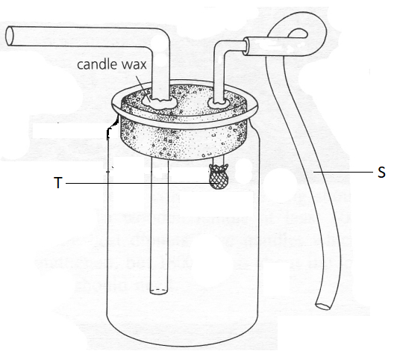

1. Name part labelled S and T. (2mks)

S –

T –

1. State the function of the apparatus. (1mk)

20. State **one** environmental problem that can be solved by studying biology (1mk)

21. During an experiment it was found out that germinating bean seeds released 9.0 cm3 of carbon (IV) oxide while 8.8 cm3 of oxygen was consumed.

1. Calculate the respiratory quotient (2mk)
2. State the type of respiratory substrate. (1mk)

1. State two conditions necessary for maintaining respiration (2mks)
2. Explain the disadvantages of anaerobic respiration in plant roots. (2mks)

22.(a) Name the excretory product removed through guttation (1mk)

(b) Name the structures in the skin that deals with (2mks)

(i) Temperature regulation

(ii) Excretion

(c) Seals have very thick layer of fatty tissue under the skin. In what way is this useful to them? (2mks)

23.(a) The diagram below represents the apical growth in a root

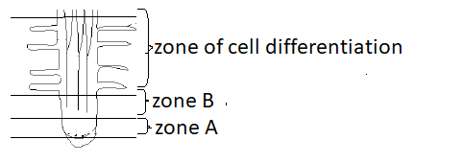

(i) What happens to the cells at zone B (2mks)

(ii) Name the hormone produced at zone A that brings about a change in zone B (1mk)

24.(a) Name the hormone that sustains the larval stage in insects and the structure that produce it. (2mks)

Hormone -

Structure -

(b) State the type of growth which occurs in insects. (1mk)

25.(a) What are vestigial structures? (1mk)

1. The paddles of whales and fins of fish adapt these two organisms to aquatic habitats.
2. Name the evolutionary process that may have given rise to such similar structures. (1mk)

1. What name is given to such structures. (1mk)

26.Name three features that distinguish man from ape even though they are closely related in the evolutionary tree. (3mks)

27.Explain why fresh water protozoa like amoeba do not burst when placed in distilled water

(2 marks)

28. State **Two** modifications of stomata which enable a plant to reduce the loss of water. (2mk)